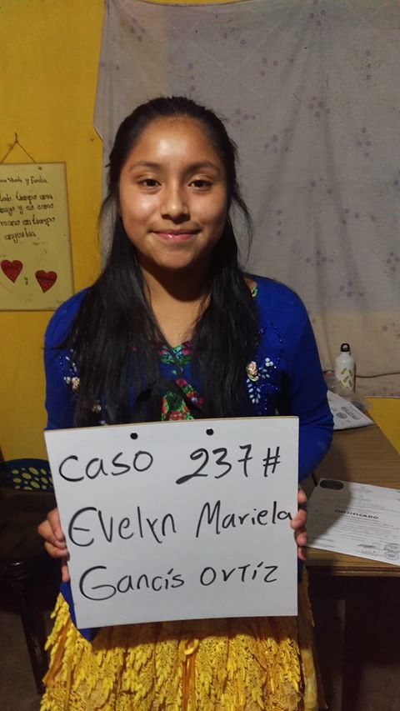
Meet Evelyn Mariela! Evelyn Mariela Gancis Ortiz was born September 5, 2002. She is the
Daughter of Rodolfo Gancis Cuy and Maria Avelina Ortiz Gomez. Her father works as a
farmer. He walks 2 hours each way to one of his fields and 1 hour each way to his other field.
Rodolfo works 12 hours a day. He speaks both Spanish and Katchiquel, a native Mayan dialect.
He has a 6th grade education. Evelyn’s mother works taking care of the house and also does
tejido. Tejido is Guatemalan weaving. She also speaks both languages and has a 6th grade
education. Evelyn has 2 brothers, ages 24 and 19, and 4 sisters who are 22, 21, 14, and 12 years
of age.

Evelyn enjoys learning and attends IMEBC school. Math is her favorite subject. In her free
time she enjoys drawing. Her future plans include becoming a doctor.

In 2014, her family received a new roof for their home from Moving Mountains Mission Team.

