377 Damaris Mishel
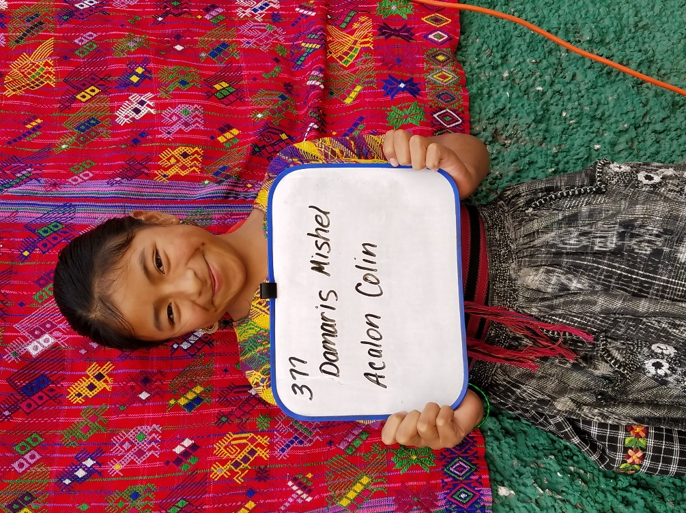
Damaris Mishel Acalon Colin was born on May 27, 2008. Her father is Oscar Acalon Vasquea and he is 36 years old. He works as a carpenter in Santa Maria. Oscar has a 5th grade education and speaks both Katchikel and Spanish. Her mother is Maria Julia Colin Garia. She is 33 years old and works taking care of the home. Maria Julia speaks both Katchiquel and Spanish and has a 3rd grade education.
Damaris has two brothers, ages 15 and 5. She has no sisters. Only her family of 5 live in the home.
She attends Escuela de Ninas in Santa Maria. Her favorite subject is Math and she doesn’t like Spanish. She would like to be a teacher. In her free time she likes to play ball.
Damaris helps her mother around the house. She speaks Spanish and a little Katchiquel.

