#310 Katerine Yadira Chavez Mixtun
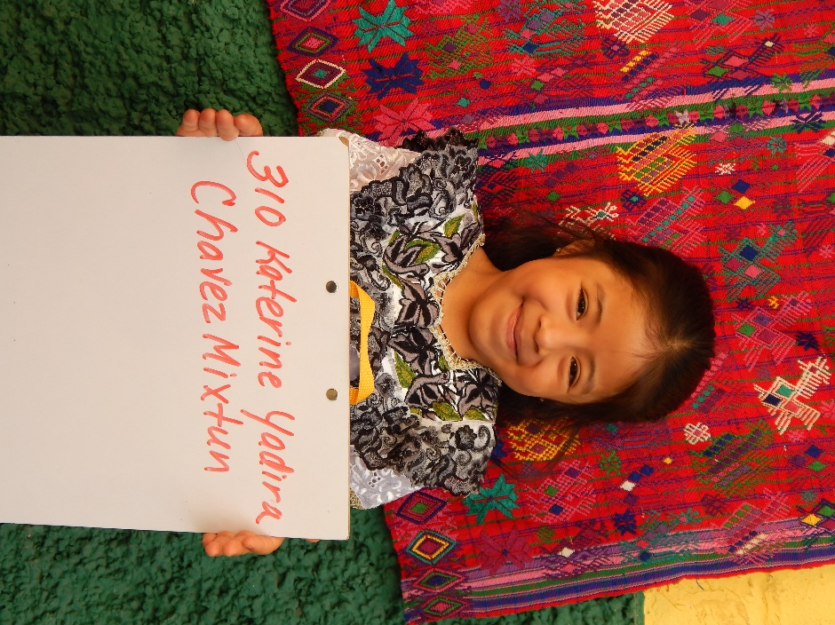

Katerine Yadira Chavez Mixtun was born 1/8/09. She is the daughter of
Julian Chavez Vasquez and Josefina Dominga Mixtun. Her father is 34 years old and works as a farmer. He walks 45 minutes each way to work in the fields. Julian speaks both Spanish and Katchiquel, a native Mayan dialect. He has a 6th grade education. Josefina works keeping the house and caring for the family. She also speaks both Spanish and Katchiquel and has a 6th grade education. Katerine has one sister.
Katerine attends Escuala de Ninas, or the School for Girls. Social Studies is her favorite class in school. Language and communication is her least favorite class. In her free time, she likes to paint. Katerine would like to become a secretary when she grows up.

