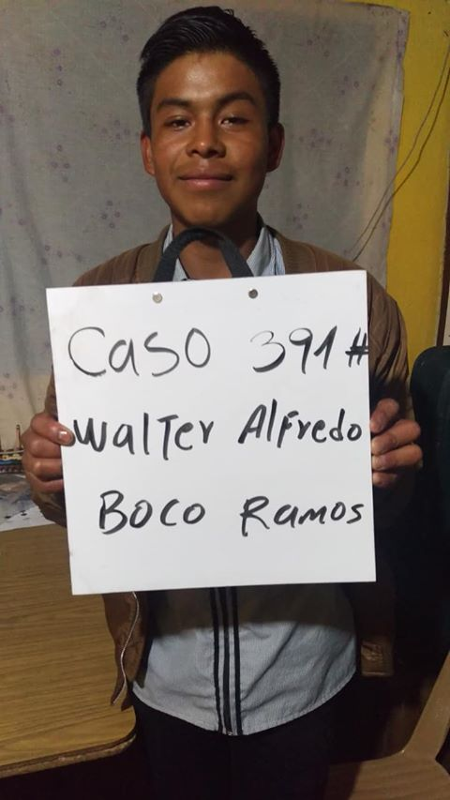
Meet Walter Alfredo! Walter Alfredo Boco Ramos was born 5/9/2002. His parents are Arcadio Boco Colin and his mother is Maria Santos Ramos Ruiz. His father works as a farmer and walks 1 hour each way to his field. Arcadio speaks both Spanish and Katchiquel, a native Mayan dialect. His mother Maria works taking care of the house. She has no formal education. Walter has 4 brothers and 4 sisters.
He attends IGPA school. Walter helps his dad in the field on Saturdays. In his free- time he likes to read and cook. His future plan is to become a chef.

