459 SUSAN MANUELA ORTIZ HERNANDEZ
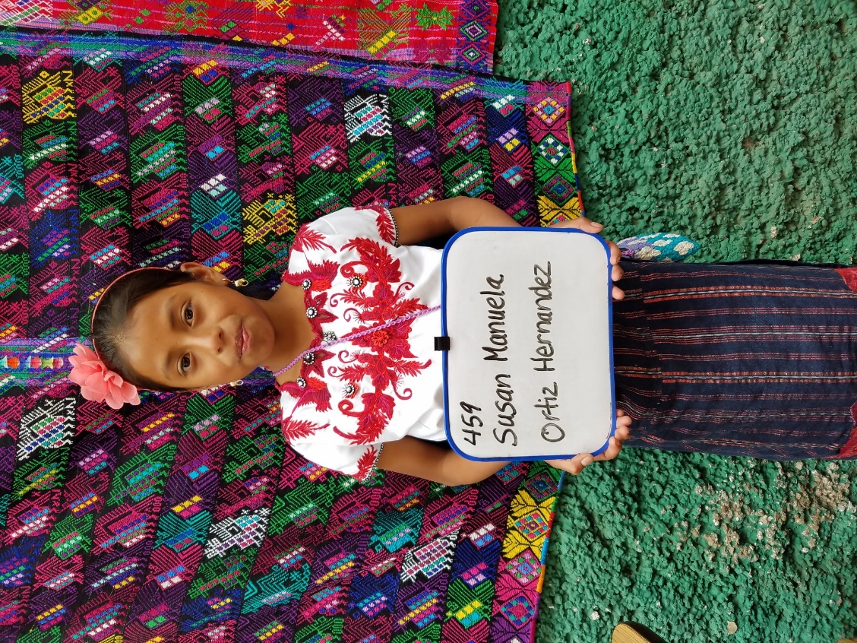
Susan Manuela Ortiz Hernandez was born 10/16/2006. Her father is deceased.
Susana Hernandez Pio is her mother. Susan does not have any brothers or sisters.
She attends Urbana Mixta school. In her free- time she enjoys reading. Her future plan is to become
a doctor.

