#434 Walter Geovanny Oron Yuman
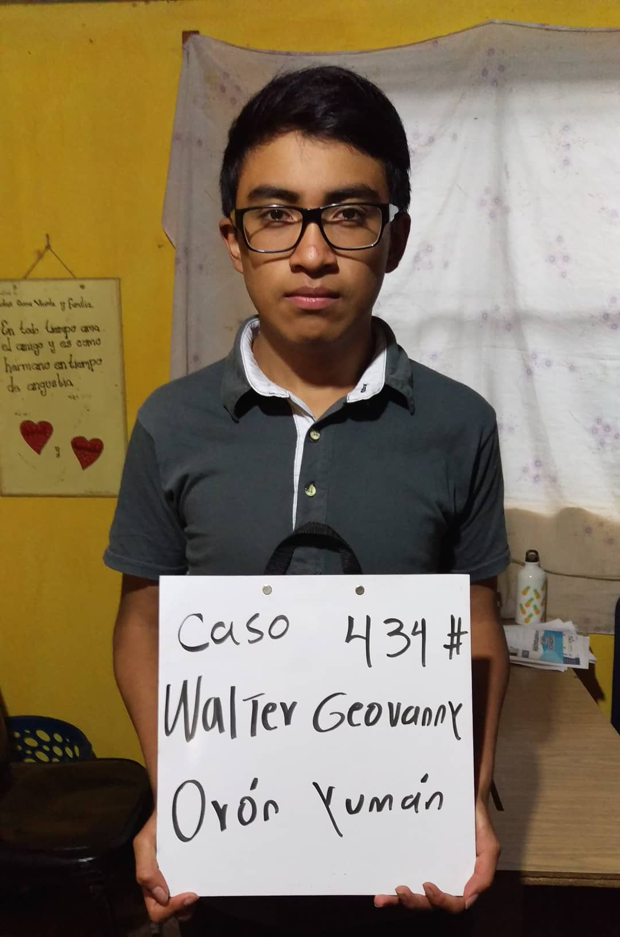
Walter Geovanny was born 9/15/2003. His father is Juan Oron Gomez. Juan is 54 years old and works as a farmer. He spends 12 hours a day in the fields. He has a 3rd grade education and speaks both Spanish and Katchiquel, a Mayan dialect. Walter’s mother is Maria Josefina Yuman Petet. She is 52 years old and works taking care of the home and family. She too has a 3rd grade education and speaks Spanish and Katchiquel. The family includes a 22 year old brother and two sisters ages 20 and 18.
Walter attends INEB INED school. His favorite subject is mathmathics. His future plans are to become an administrator.

Maria Josefina Yuman Petet.

