#11 Claudia Veronica Tepaz Mixtun
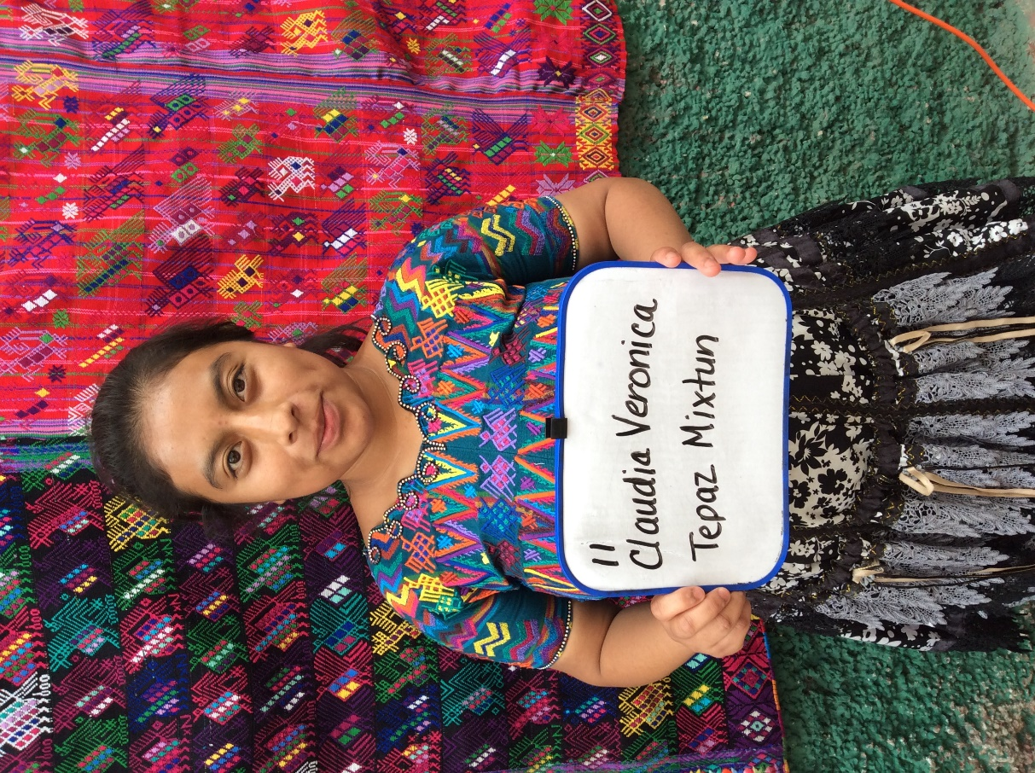
Meet Claudia Veronica. She was born 3/8/2000. Her father is Juan Tepaz Antun. Her father is 45 years old and works as a farmer. Juan walks 1 ½ hours each way to his field. He speaks both Spanish and Katchiquel, a native Mayan dialect. Her father has a 4th grade education. Claudia’s mother is Maria Melasia Mixtun Chocoj. Maria is 42 years old and works taking care of the house. She also speaks both languages. Her mother has a 3rd grade education. Claudia has a 14- year old brother and a 10 -year old sister.
Claudia is currently attending school to be an auxiliary nurse which is equivalent to an LPN in the United States. Next school year, which begins in January she will be attending the university to become a professional nurse or RN. Claudia enjoys studying and her favorite subject is math.
In 2015, her family receive a new roof through Moving Mountains Mission.

