#343 Brayan Josue Hernandez Perez
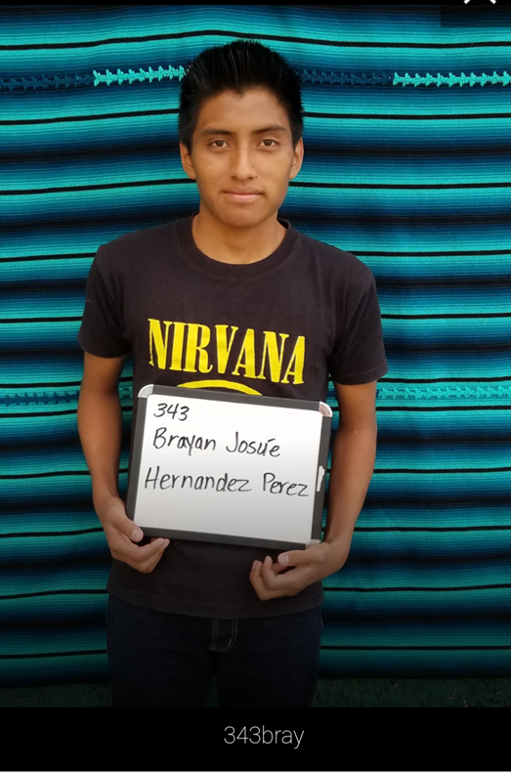

Brayan was born December 10, 1999. His father is Juan Hernandez Lorenzo. His father works as a farmer and walks an hour and a half to his field. Juan Hernandez speaks both Spanish and Katchiquel. Brayan’s mother is Aura Leticia Perez Cuma. She works keeping the home. She has a 6th grade education. Brayan has a 16 year old brother and a 7 year old sister.
Brayan speaks only Spanish. There are 14 people living in their home.
He is in his final year studying electronics and digital imaging.

Bry

