#303 Sandra Ortiz Perez

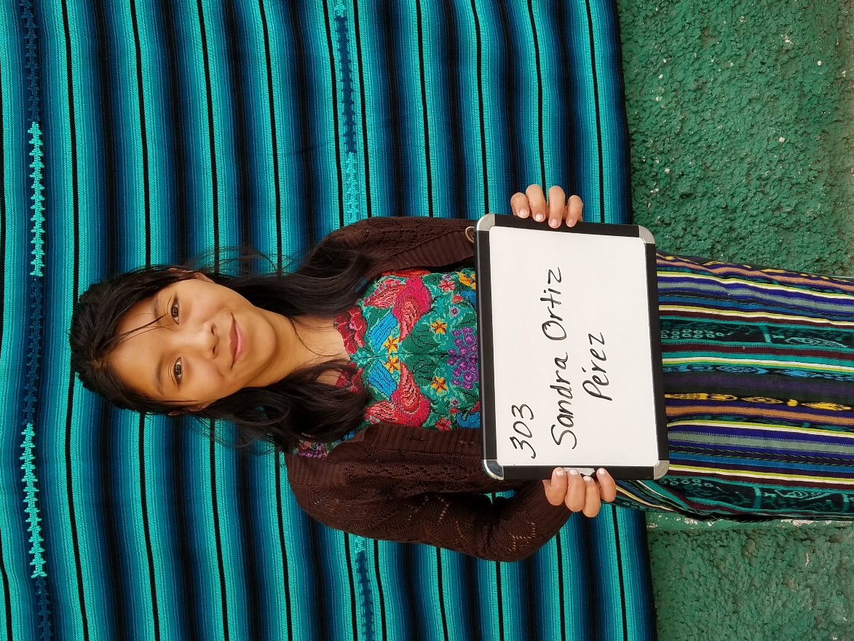

Sandra Ortiz Perez was born July 1, 1999. Her father is Leon Ortiz Ortiz. Her mother is Juana Perez Cuma. Sandra has 5 brothers and 4 sisters.
She is now enrolled at the University and is studying Hotel and Tourism Management.

