#465 ALEJANDRA GUADELUPE MIXTUN XAR

Alejandra was born May 9, 2006. Her father is Jose Avilio Mixtun Colin. Her mother is Evelyn Rosio Xar Vasquez. She has two sisters.
Alejandra attends Angelitos de Dios School. This school is next to the large church near the central park in Santa Maria de Jesus. She likes to study English but does not like Katchiquel. Alejandra hopes to become a doctor one day. In her free time, she enjoys painting.

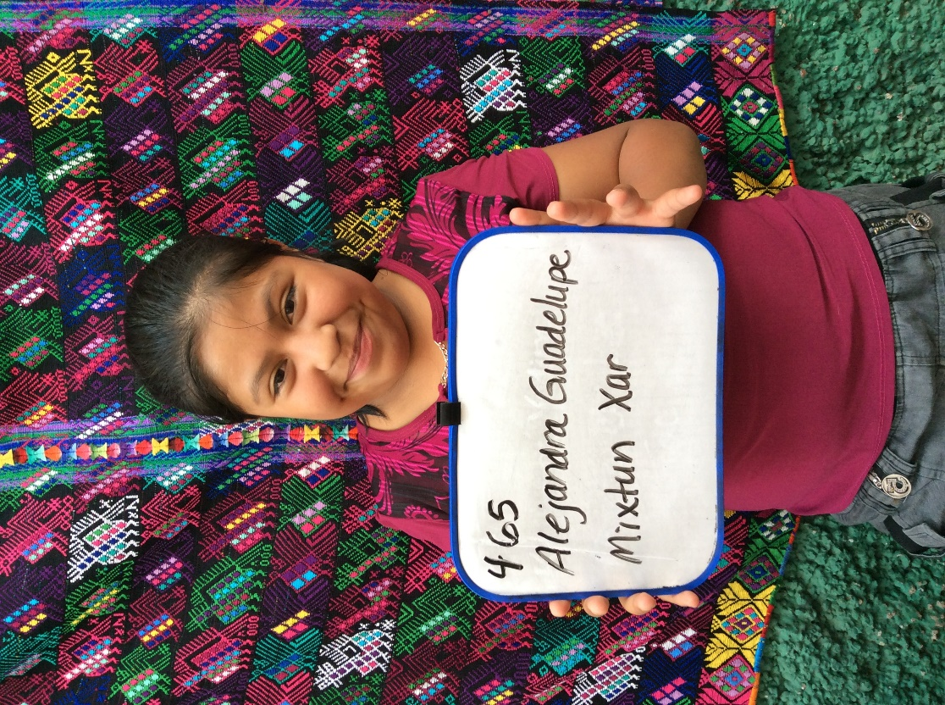
Note: Alejandra is relatively new to the sponsorship program and was not in the program at the time when I did home visits. Let me know if there is any additional information you would like and I will see if I can get it for you.

