#283 Carol Isabel Acalon Valle
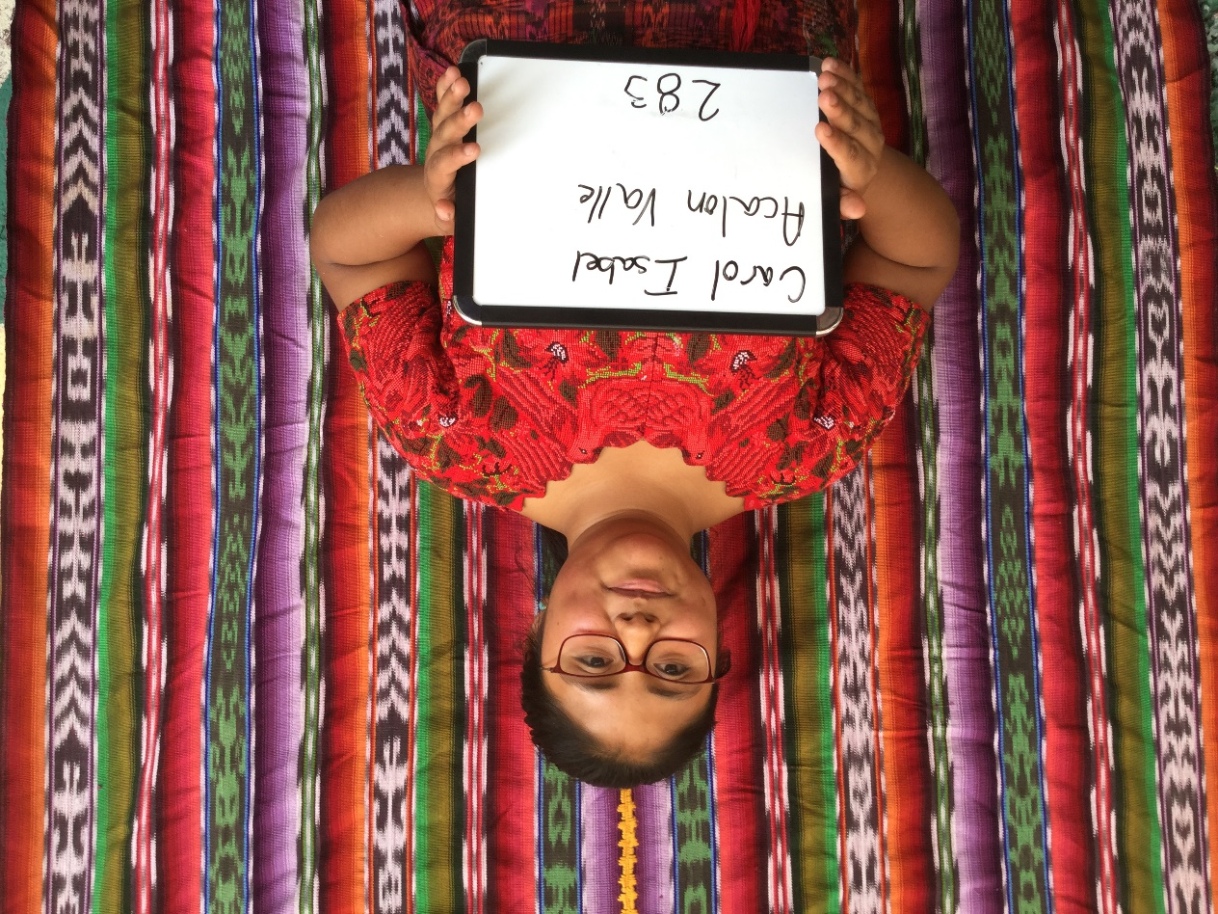

Carol Isabel Acalon Valle was born 12/12/2000. Her father is Jose Leonel Acalon. Jose Leonel works at a Hotel in Antigua and is 39 years old. He speaks both Spanish and Katchiquel, a Mayan dialect. Jose has a 6th grade education. Carol’s mother is Gladis Isabel Valle. She works caring for people and has a 3rd grade education.
Carol has 2 brothers, ages 13 and 9, and one sister aged 17 years old.
Carol is currently attending INSOL school and hopes to become a psychologist.
In her free time she likes to read.

