#464 Marlen Elizabeth Cuca Castellanos

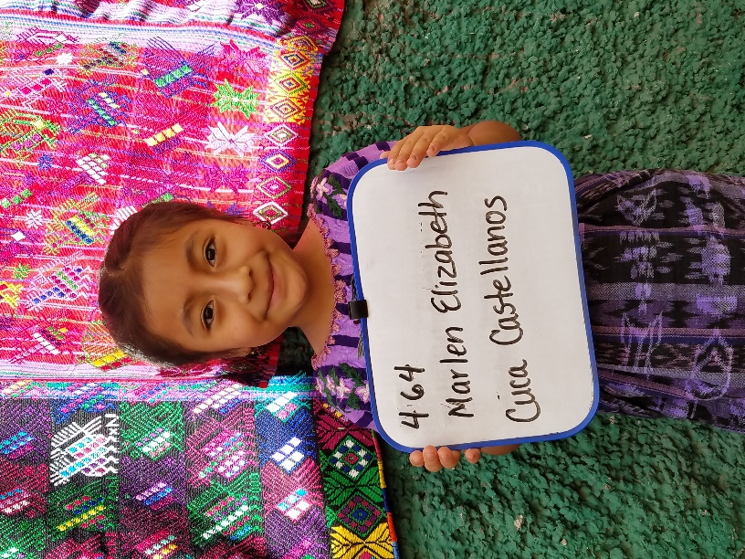
Marlen Elizabeth was born April 27, 2010. Her father is Hector Leonel Cucu Perez and her mother is Rosa Elizabeth Castellanos Lorenzo. She has two sisters.
She attends Escuela de Ninas which is the school close to central park in Santa Maria de Jesus. Marlen enjoys drawing in school but she doesn’t like to write.
Marlen hopes to become a doctor someday.

