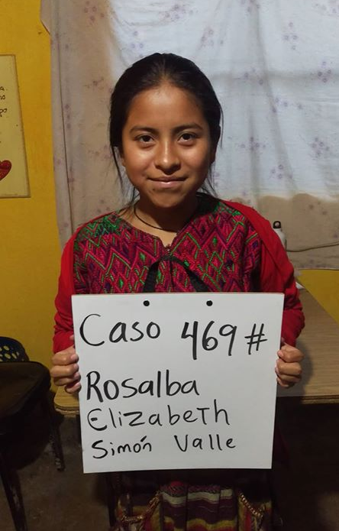

Meet Rosalba Elizabeth! She was born 1/17/2005. Her father is Irieno Sunun and her mother is Margarita Valle. Rosalba has 1 brother and 8 sisters. She attends Escuala de Ninas school which is very close to central park in Santa Maria. Rosalba enjoys art in school but does not like math. In her free time she likes to draw. She would like to become a teacher.

