#555 Angel Miguel Chavez Simon

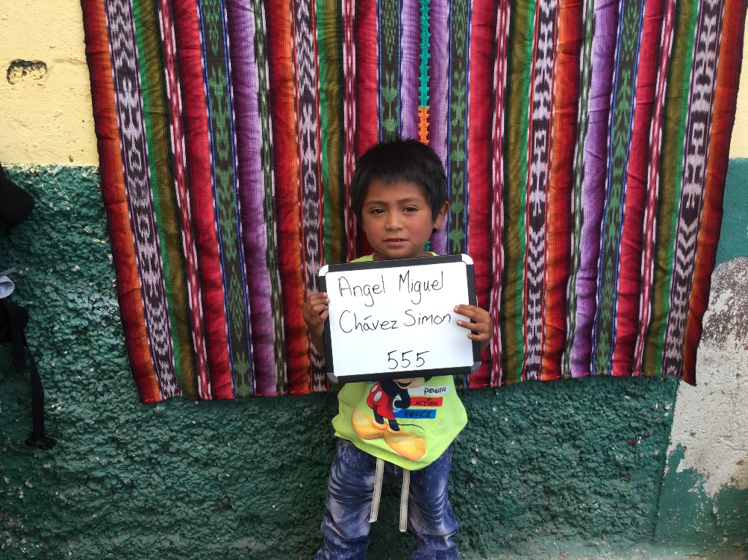

Angel Miguel was born 11/19/2013. His father is Miguel Angel Chavez and his mother
is Maria Rosalia Simon Otsoy. He has one brother. Angel is in kindergarten and attends Nuevo Milenio
School in Santa Maria de Jesus, Guatemala. In his free- time he enjoys playing. When he grows up he
would like to be a doctor.

