375 Ceasar Armando Acalon Ruiz

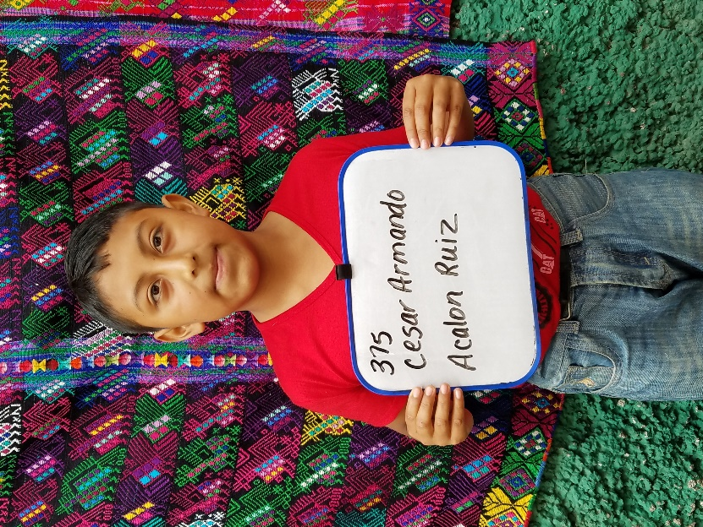

Cesar Armando Acalon Ruiz was born May 27, 2008. His father is Domingo Acalon Livar. Domingo is 43 years old and works as a security guard at a business in the capital. He speaks both Spanish and Katchiquel and has a third grade education. Cesar’s mother is Estela Ruiz Jimenez. She is 33 years old and works as a housewife. Estela also makes tejido, which is Guatemalan weaving. She has no formal schooling. Cesar has a sister who is 8 years old.
Cesar attends Urbana Mixta School. He likes to do his homework. His future plans include becoming a fireman.

