#487 Luis Fernando Chavez Patan
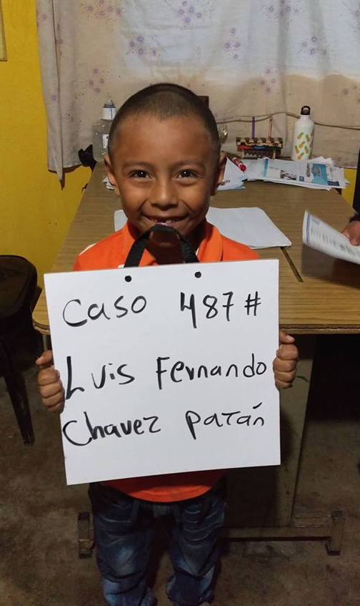

Meet Luis Fernando! He was born on September 1, 2011. His father is Rigoberto Chavez Cumar.
His mother is Leona Patan Vicente. He is an only child. He attends Urbana Mixta School. When asked
about his future plans he replied “work with my dad on machines”.

