#161 Mario Daniel Gomez Yuman
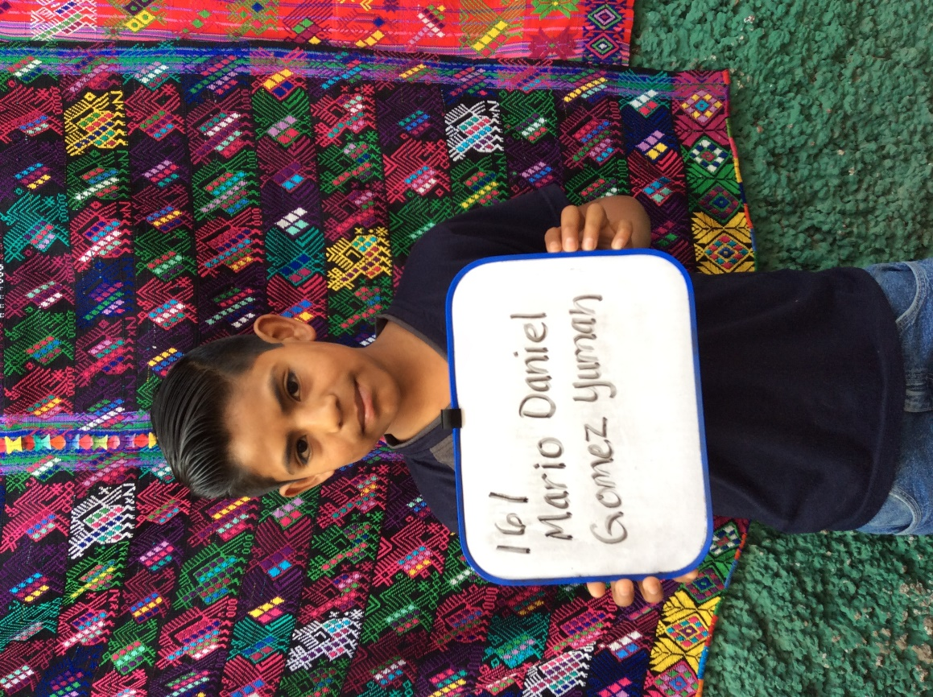
Mario Daniel was born on September 2, 2005. His father is Felipe Gomez Jimenez. He is 48 years old and works as a farmer. Felipe walk 1 ½ hours each way to work in fields. He has a 6th grade education. Mario’s mother is Maria Margarita Yuman Ortiz. Maria works taking care of the home and family. She also does tejido, which is Guatemalan weaving. His mother has no formal schooling but does want her children to stay in school. Mario has a 19 year old brother and a 25 year old sister.
Mario attends Marianno Navarette school where he enjoys studying Math. In his free time he enjoys playing basketball. His future plans are to become a teacher.

